Asilo, Rainier

Mariano, Jorjo

2 ECE – A

**Machine Problem 4**

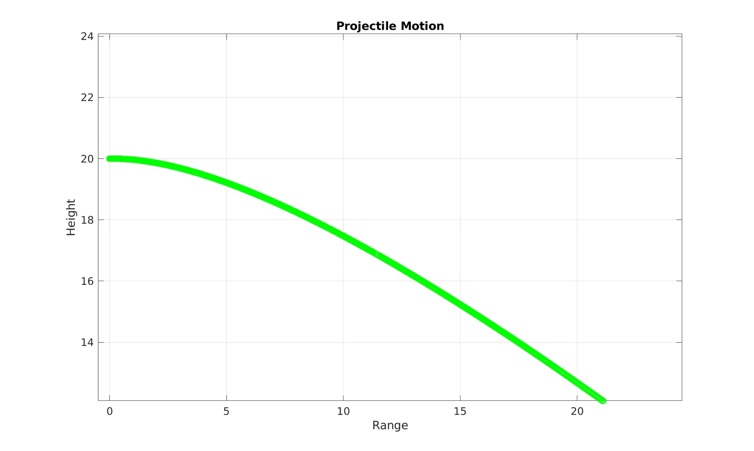

h = 20

Vo = 10

Angle = 45

Ax = 10

Ay = -9.8